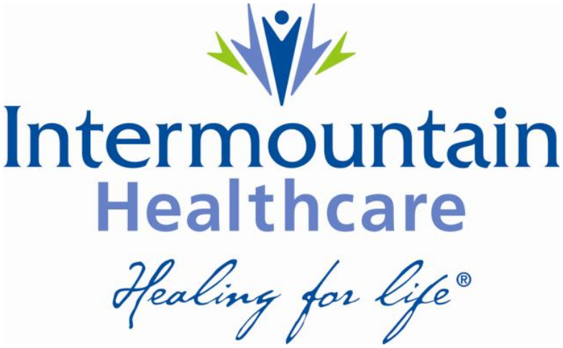

28 November 2014
Enterprise Architecture White Paper
The Role of NoSQL at Intermountain Healthcare

Johnnie Harris

Contents
Introduction 3
NoSQL Defined 3
Data Store Types for NoSQL 3
Comparison to RDBMS 4
Risk and Benefit analysis 6
Which NoSQL solution fits best for Intermountain Healthcare 6
Conclusion 6
Appendix A 7
References 8
Index 9

Introduction

Healthcare has been slow to adopt the non-RDBMS technology that is often referred to as NoSQL. NoSQL may be referred to as “No SQL”, referring to the fact that this technology does not use the declarative language and standard called SQL. However, more commonly, the term is known as “Not only SQL” which seems to embrace the idea that this technology is a superset of the relational database.

This paper aims to describe the advantages and dis-advantages of using NoSQL in the Healthcare industry.

NoSQL Defined

NoSQL is an enabling technology. It enables the managing of data generated by large-scale applications. The most common characteristics among the many different NoSQL systems are that they are schema-less, tend not to be ACID-compliant and are designed to be highly distributed.

In order to describe the pros and cons it is important to first agree to an understanding of what NoSQL is and is not. As with most popular, trending, technologies NoSQL did not start out as a standard with a well-defined vocabulary. Instead it has been shaped by the different non-RDBMS implementations which have succeeded. To this end it makes sense to understand NoSQL in terms of what has been implemented and the features that make these implementations successful and by the unique feature or features that different users find useful.

NoSQL is described as a group of progressive data management engines that go beyond legacy relational databases in order to meet the growing needs of modern business applications (Datastax Corporation, 2013). Additional description is an engine that allows a very flexible data model, horizontal scalability, distributed architectures, and the use of languages and interfaces that are “not only” SQL – these are common characteristics of NoSQL technologies.

Data Store Types for NoSQL

NoSQL data stores are grouped into various categories. Each category describing, in a general way, the method of storage. Each method has its own unique set of characteristics that make it a good choice for a typical set of use cases. It is the responsibility of those designing the system that need to ensure that these capabilities are correctly matched with the functional and non-functional requirements of the system under design.

Key-Value Store

Key-value stores keep the key and value as objects and make good stores for highly variable data (Amazon.com, 2007). Key-value stores grew out of the need to rapidly scale simple data collections. These engines are highly optimized to automate the “sharding” process (i.e., splitting the data and distributing it across multiple nodes in a massively parallel environment). Data is added and read, but rarely updated in these systems.

Document Store

Document stores have keys and objects formatted as documents and stored in a hierarchical tree-like structure. The documents are usually described in some kind of notation. One popular format is JavaScript Object Notation (JSON), which is supported by multiple languages and makes it easy if the use cases require flexible schemas.

Graph Store

Graph databases describe relationships between entities and support complex traversal of the object graph.

Table-Style Store

Table-style databases are somewhat like RDBMSs. They are defined as row and column structures, however they are not based on SQL or any other relational assumptions. These structures still embody the idea of flexible schemas, can handle greater scale and have less restrictive transactional consistency rules.

Comparison to RDBMS

The best way to compare and contrast relational database management systems (DBMS) with NoSQL DBMS is to understand the changing requirements of today’s applications versus those of decades past. Here we depict some important distinctions (Datastax Corporation, 2013):

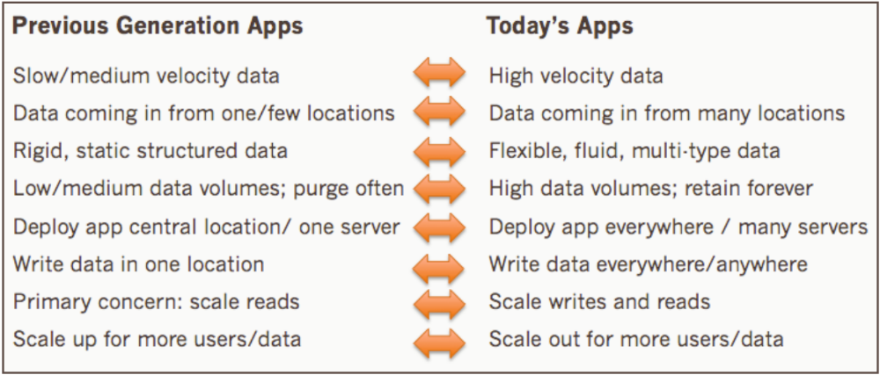
Figure 1 - How legacy and modern application needs differ with respect to data
As time progressed and technology advanced the requirements for performance, scale and rapid development grew to unprecedented levels. The RDBMS was unable to meet the shifting requirements of these massive online applications.

The architectural limitations of RDBMS became more evident. RDBMS like Oracle were scale-up, master-slave, non-distributed architectures. Modern online applications had to have the ability to divide-and-conquer in such a way as to be configured for processing large amounts of data at very high speeds.

Any engineer or analyst working with legacy RDBMS know the difficulty and limitation of working with a highly structured, inflexible data models. NoSQL based solutions provide a big answer to this limitation. There are many use cases across the industries, including health care, that contain a mixture of structured, semi-structured and unstructured data. Traditional RDBMS are not efficient at working with dynamic data models, or unstructured data. This is especially true in the health care industry today as we move closer and closer to inundating the health care space with machine-generated data or time series applications.

The traditional RDBMS is built in a scale-up, master-slave design. In other words these legacy data stores are not elastic. NoSQL technologies have been built from the ground up to scale-out, providing elasticity and able to meet difficult performance SLA’s required by many online applications. This is a very important requirement in the health care space. Additionally, the elasticity of the NoSQL technologies provides better distribution for a wider, geographically dispersed, user space.

In order to scale-up to handle high speed data, or a geographically dispersed user base, an organization must pay a high price with technologies like Oracle. This is exacerbated by the fact the legacy RDBMS cannot attain the needed requirements to handle high velocity, unstructured data even when large amounts of dollars are expended trying to fit a square peg into a round hole. Peter Goldmacher with Cowen and Company did an analysis of organizations increasingly moving to newer data management technologies that offer more “robust” and “flexible” technologies at “dramatically lower prices” (Goldmacher, 2013).

Risk and Benefit analysis

Discuss the risks and benefits. Including performance, cost, scalability, development.

Which NoSQL solution fits best for Intermountain Healthcare

Discuss the various solutions and recommend.

Conclusion
Recommendations and conclusions.

Appendix A

Placeholder for appendix.

References
Amazon.com. (2007). Amazon Dynamo Sosp2007. Retrieved from allthingsdistributed: http://www.allthingsdistributed.com/files/amazon-dynamo-sosp2007.pdf
Datastax Corporation. (2013, October). Comparing Oracle with Cassandra/Datastax Enterprise. Retrieved from Datastax: http://www.datastax.com/resources/whitepapers/comparing-oracle-with-cassandra-datastax-enterprise
Datastax Corporation. (2013, October). Why NoSQL? Retrieved from Datastax: http://www.datastax.com/resources/whitepapers/why-nosql
Goldmacher, P. (2013, June 21). 4Q Miss: Mgmt Blames the Macro, We’re Not so Sure. Retrieved from Cowen and Company: http://goo.gl/VLQE50

Index

C
cost · 6
D
Document · 4
E
elastic · 5
F
flexible · 3, 4, 6
G
Graph · 4
H
health care · 5
Healthcare · 3, 6
J
JavaScript Object Notation · 4
JSON · 4
K
Key-value · 4
Key-Value · 4
M
master-slave · 5
N
NoSQL · 3, 5, 6
O
Oracle · 5
P
Peter Goldmacher · 6
R
RDBMS · 3, 4, 5
robust · 6
S
scale-up · 5
SLA · 5
T
Table · 4
V
velocity · 6

